Reg. No. CODE: SPH2

PH. D COURSEWORK EXAMINATION, MAY 2023

SUBJECT: AEROSPACE ENGINEERING

SPECIALIZATION PAPER 2 - ENERGY AND VARIATIONAL METHODS

Time: 03 hours Maximum Marks: 50

Name: K Selvakumar

Instructions:
- Section A Compulsory
- Answer any four from Section B
- Each question carries 10 Marks

SECTION A

Answer the following question: (10 Marks)

a) State the principal of minimum potential energy and principle of minimum complimentary energy principle. Give their mathematical statements. (5 Marks)

b) Write the main differences between the Galerkin and Rayleigh Ritz methods. (5 Marks)

SECTION B

Answer any four from the following question: (Each carrying 10 Marks)

- Solve the following problem using 1 term and 2 term Rayleigh Ritz solution. (10 Marks)
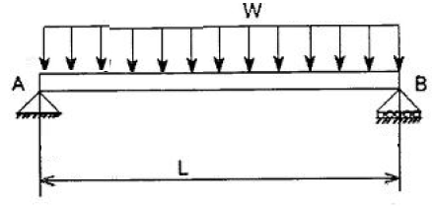

- Consider the Functional
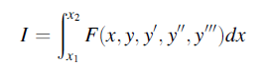

Derive the Euler Lagrange Equations and the Kinematic and Natural Boundary conditions. Discuss the different possible combination of Boundary conditions at the ends x=0 and x=L. (10 Marks)

- Discuss the Reissner Variational Principle of Elasticity. Give the mathematical statement of the principle. What will be the Euler Lagrange Equation of this principle? Illustrate your answer with an example. (10 Marks)

- Use Castigliano Second theorem to determine deflection at the midpoint of the Propped cantilever beam shown below. (10 Marks)
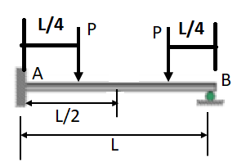

6) Let us consider the example of a simply supported beam under uniformly distributed load as shown in the figure below.
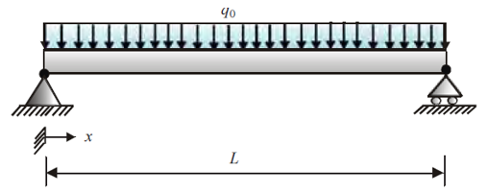
Establish the Governing Differential Equations and the boundary conditions using the principle of Minimum Potential Energy. (10 Marks)

7) .

a) Explain using an example the strong form and the weak form of the variational function. Discuss the benefits and limitations of both the forms. (5 Marks)

b) Establish the weak form of the following Governing differential Equation.

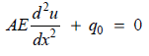

(5 Marks)

********

